Heartland Christian School 2026-27 Classroom Supply List
Each family should bring the following:

- 1 Bathroom Cleaner spray bottle
- 1 Pkg trash bags (13 gallon)

- 3 Reams copier paper
- 4 Boxes Kleenex
- 3 Rolls of paper towels
- Pkg. PAPER plates (100 or more) No Foam
- Pkg. of plastic spoons AND forks (100 or more)
Second Grade:
1 Insulated Lunch box/bag
8 Dry erase low odor, black, fine point markers
1 personal Bible (NIV recommended)
1 pkgs Dixon Ticonderoga pencils Only
1 small plastic pencil box w/ snap lid (no locks)
2 Pink erasers
1 Box 24 Crayola colored pencils
2 Boxes Crayola Crayons
1 pair of Fiskars scissors (pointed tip)
2 Plastic (heavy duty) 2 pocket file folder (no brads)
2 pkgs small glue sticks
1 Pkg Astrobright colored cardstock – bright assortment

Third & Fourth Grade:
1 Box 24 ct Crayola Colored Pencils
1 Small Pencil Box with snap lid
1 Personal Bible (NIV recommended)
1 Pair Fiskars pointed scissors
1 Insulated lunch box
1 Insulated water bottle for desk
1 set of 5 miscellaneous colored fine-tipped highlighters
1 composition notebooks
1 Backpack style book bag
1 Pk loose leaf wide ruled notebook paper
1 Pk of #2 pencils or mechanical
4 Pk of expo markers any color, with chisel tip

Preschool:

1 - 24ct or less Crayola (only) crayons
1- 8-count Crayola or Prang watercolors
2 Glue sticks
1 Small pencil box w/snap lid
2 Expo dry-erase markers (Black only)
Water bottle with Lid
1 Zip closure Backpack-Style Bookbag

Kindergarten:
1 Backpack- Zip Closure (big enough for
9x12 folder)
1 Insulated Lunchbox
1 Ream of cardstock - white

First Grade:
1 Insulated Lunch box/bag
1 Reusable water bottle
4 Dry erase markers (any colors)
2 FINE TIP expo markers (low odor)
1 Backpack-large enough for 9x12 folder
1 Personal Bible (kids Visual Study Bible)
3 Erasers
12 Pencils (Ticonderoga are the best!)
1 box of Crayola crayons
1 box of Crayola markers
1 box of colored pencils
4 glue sticks2 spiral notebooks - wide rule
1st through 6th grades need P.E. Shoes
1 pair of scissors (small, pointed tip)1 12" ruler
1 3 ring binder (any color/style)

1 extra set of clothing
1 art day shirt or apron (to cover clothes when
painting)

Fifth through twelfth grade supply list on back

Secondary Supply List:
(Classroom teachers may request other items as needed)
Bible
Pens and Pencils (some colored pens)
2 Sharpies
1 - 3-ring binder
6 - 3-hole pocket folders
Colored pencils and markers
Notebook paper or notebooks for each class
One Ream of Copy Paper for Homeroom Teacher
2 Glue Sticks
Ear Buds / Headphones
Small dry-erase board
- 2 Highlighters
Tl - 30X11S Calculator
Protractor
Compass
Scissors
Ruler
Journal Notebook
2 Expo dry-erase markers
1 Pkg graphing paper
P.E. shoes are needed if taking P.E.

Fifth & Sixth Grade:
1 Backpack style book bag
1- 1-inch binder (dividers optional)
Insulated Lunchbox
1 Insulated water bottle for desk
1 - 12" ruler (Metric & Standard Measurement)
1 Box Colored Pencils (optional)
1 Package of #2 Pencils or mechanical
2 Square erasers
1 Standard Size pencil box/pouch to fit inside desk (optional)
8 to 10 Expo dry-erase markers
1 Protractor and l- Compass
1 Personal Bible (NIV recommended)
1 Package of pens (any color but black)
2 Highlighters
1 Journal or notebook
1 - 2 Pocket folder
Calculator (6th grade required, 5th grade optional,
must be a scientific calculator)

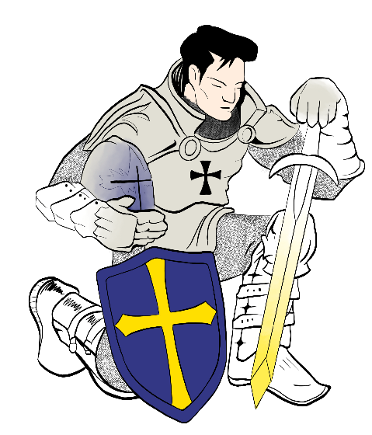

Heartland Christian School
1995 W. 4th Street, Colby, KS 67701
www.hcscolby.org 785-460-6419

